

**HOSPITAL BYSTANDER MANAGEMENT WEB SYSTEM**

M.Jasman

15APC2341

Department of Computing and Information Systems

Faculty of Applied Sciences

Sabaragamuwa University of Sri Lanka

2020

# **DECLARATION**

I declare that this thesis does not incorporate, without acknowledgment, any material

previously submitted for a Degree or a Diploma in any University and to the best of

my knowledge and belief, it does not contain any material previously published or

written by another person or myself except where due reference is made in the text.

Also, I hereby grant to Sabaragamuwa University of Sri Lanka the non- exclusive

right to reproduce and distribute my thesis, in whole or in part in print, electronic or

other medium. I retain the right to use this content in whole or part in future works

(such as articles or books).

Name of Student: M.Jasman

Signature of Student:

Date:

# **Certification of Approval**

We hereby declare that this thesis is from the student’s own work and effort, and all other sources of information used have been acknowledged. This thesis has been submitted with our approval.

………………………. ………………………….

Head of the department Date

…………………………. ………………………….

Internal Supervisor Date:

**ACKNOWLEDGEMENT**

It is with respect I express my sincere thanks to God Almighty firstly, because he has

given the opportunity and made the time available for all process of this research

project. I am obliged to thank to my Supervisor Dr.B.T.G.S.Kumara, Head of the Department,

Department of Computing and Information Systems from whom I obtained proper

guidance in the process of completing the project. The main objective of any computer science student is to get as much of practical knowledge as possible. Being an able to have a practical knowledge by developing a project is a lifetime experience. As practical knowledge is as important as theoretical knowledge, I’m thankful of having this project. Therefore I also extend my thanks to my lecturers and to Department of Computing and Information Systems for giving

me best education support which helped me in many ways for this project works.

I would like to thank my dear friends Thiyagarasa Nirosan and huge thanks to my

seniors Kanakaretnam Mayooran scholarly advice enabled me to successfully complete the mini-project.

Finally, I would also like to extend my inner most thanks to my family members for

their utmost patience during my studies. I thank them for the continuous

encouragement, moral and unreserved best wishes and. I dedicate this Project to my

beloved family members.

-Project Developer

**ABSTRACT**

In the medical field, there are hand-full of medial channeling applications and online pharmacy systems. But those are designed to satisfy the requirements of economically higher class people. But this proposed system covers the entire set of people who need the human assistance.

This system is the timely need for the people who need the human assistance, since most of the family types in the urban cities are nuclear families. Even the family members are ready to care taking, but they don’t know the proper way of care taking practices. But this system facilitates the care takers to get the sufficient knowledge about care taking through the toll-free systematic workshops. According to the survey, there is no similar type of systems related with the same care taking aspect. So there will be a gap can be identified. By this system, the evolving gap for the care taking can be fulfilled with effective manner.

This application has the data base of the registered caregivers, their locations and availability. Once if some wanted to hire a care giver through the app, they wanted be to open this web page and find out the care giver nearby their location. Then they want to book them for their required days. To complete their registration they want to pay the fee for the service. The payment can be made through the online portal or by bank to the system. Once the system received the payment, it will inform the responsible caregiver about his duties regarding the request made. The Bystander Management system is developed based on the waterfall mode development framework as this is a traditional system there are no changes on the system requirements so the waterfall model is useful for this development. Laravel is used to implement this system, further SQL server database is used to store the data and information of the system.

**Table of contents**

**List of figures**

Figure 3.1 Use case diagram for EBS ------------------------------------------------------

Figure 3.2 Database Design (ER diagram) ------------------------------------------------

Figure 1 Waterfall Model --------------------------------------------------------------------

Figure 2 Home Page Interface ---------------------------------------------------------------

Figure 3 Employee Register Forms -------------------------------------------------------

Figure 4 Patient Register Forms ---------------------------------------------------------------

Figure 5 Admin Dash Board----------------------------------------------------------------

Figure 6 Employee Data Table ------------------------------------------------------------

Figure 7 Admin Chart ----------------------------------------------------------------------

Figure 8 Validation Code ------------------------------------------------------------------

**CHAPTER 1 – INTRODUCTION**

**1.1 Introduction**

Now the day nuclear families are the most common family structure, only possess limited number of family members, such as father, mother and children. It’s a very sound family structure when it comes as financial aspect, but in other hand if someone gets hospitalized, then the story become very worse. Because if someone has hospitalized in a nuclear family. Then the rest of the family members wanted to be take care of the hospitalized person and the rest member’s responsibilities become increased. Once if there any surgical condition or some other worst medical condition then one bystander wanted to be with the hospitalized person, but this is not possible in every families. Some families have only one male member, so that there will be a lack for bystander with the patient, as well as if there is only one female member then no male person can be stay as a bystander with the female member in female wards in Government hospitals. At this point there is a considerable gap will be evolve for a suitable bystander. The suitable stance for a polite, knowledgeable and accountable person. Currently the gap is filled by some local hired persons, but there is no proof that the bystanders are the ideal person for the services. Most of the time the hired persons are only concern about the money given by the family members. And they are not good enough in caretaking.

This web system mainly consider on providing polite accountable trustworthy person fore caretaking service.

**1.2 Major Goals and Objectives of this project are:**

* To ensure the better caretaking service for hospitalized persons.
* To track the service quality of the care takers.
* To avoid the forge activities of local people.
* To employ well trained and service minded people for care taking sector.
* To give training for subscribed care takers,

**1.3 Motivation**

Web base applications are predominantly increase the possibility to sort out lots of issues, mainly these kind of applications facilitate the opportunity to find out best service in real time. OLA and Uber are the real world examples where a web base application sort out the issues in finding taxies in fair rate at any time. By the way it also offering the best profit model for the developer. This approach has impressed me to tackle the problem in medical field with a profitable manner.

**1.4 Scope of the Completed projects**

Scope of this project is developing the web-based system within MEAN stack and can access via the Internet. This project split into the several modules.

• Authentication module

Only administrator, employee and user can access to this system.

• Admin module

Administrator can Manage the users including add, delete, update users and can manage the employees. Admin can view the profiles of employees’ details.

• Employee Module

Employee enables the employee to register the system and give the response to the patient request.

• User Module

The patient to register the system and hire the employee.

By developing the system, the following features are attained:

* Easy to handle and feasible
* Cost Reduction
* Fast and Convenient
* User friendly interface
* Fast access to database
* Less error
* More Storage Capacity
* Search facility

* 1. **Major Assumption**

It can be assumed that

* Throughout this application the developer expect a hazel free environment to arrange a well-qualified health care taker very easily.
* It can reduce the pre and post struggles with the care taker and the hirer.
* It will be agate way for a handy application which facilitates the booking process In a rapid manner
* In future through-out the training it can be a well-recognized platform for hiring self-care employees
* Due to the nature of the family structure this application going to be a compulsory in few years.
* Booking of the care taker through the app and rating of the care taker gives an impressive model for the application expecting a huge response among the user
* In future the profit earning model has a high potential to bloom and expecting 100% profit margin
* Expecting the first comer advantage in this field helps to the sustainability in future prospective.
  1. **Major Outcomes**

The following outcomes are expected by the developer

* an application base on care takers and hirers
* improving and well establishing a network among the care takers
* sustainable supply of care takers
* improvement of the knowledge of care takers in the field
* development of friendly service in fair charge
* earning profit throughout application
* create job vacancies
* satisfy the customers through the responsible and accountable services
* create a part time job platform in caretaking sector

**CHAPTER 2-BACKGROUND**

**2.1 Context**

This system is the timely need for the people who need the human assistance, since most of the family types in the urban cities are nuclear families. Some families have only one male member, so that there will be a lack for bystander with the patient, as well as if there is only one female member then no male person can be stay as a bystander with the female member in female wards in Government hospitals. At this point there is a considerable gap will be evolve for a suitable bystander? The suitable stance for a polite, knowledgeable and accountable person.

**2.2 Identify Problems**

* Less number of service good quality care takers.
* Requirements of patient for a caretakers change with their health conditions.
* There is conflict between patients and caretakers.
* If a patients are unable to navigate the web system, they will leave as they quick as they come due to their lack of knowledge.

**2.3 Potential Stakeholders**

Potential stakeholders of this system are;

* Admin

The administrator to manage the employee and patient. Admin can view the profiles of employees’ details.

* Employee

The employee to register the system and give the response to the patient request.

* Patient or user

The patient to register the system and hire the employee.

**CHAPTER 3- SPACIFICATION AND DESIGN**

**3.1 Requirements Document**

The first step of the project is gathering and identify the requirements correctly and prepare the requirement document. This document must be understood and very clearly.

There are two types of requirements. They are functional and non-functional requirements.

Functional Requirements:

* Register form & Login system for the care taker
* Login & Resister form for Patient
* Admin Login
* Randomly search the Employee and fix for hire.
* Rating for the site for get to know our service quality.
* Online services for clarify the doubts
* Employee, Patient can edit, view, delete their profile.
* Available

Non-functional requirements:

**1. Usability** This is a web system which able the users to easily use. Even uneducated peoples can easily access and operate it because it is designed with best user interface.

 Efficiency of use I am using latest technologies to build this system so it will takes less times to users to achieve their goals. Enable users to complete tasks without any help.

 Low perceived workload Normal people can accomplish a particular task in first attempt or second attempt but they can accomplish the task in few attempts.

**2. Security** User can see our details. They will never make your details disclosure to anyone (Because unauthorized users can’t access the system without email and password). Employees can modify the details.

**3. Reliability** The system will be developed in a manner to reduce the system failures. I will release the system which have less error, bugs in the code so that it can reduce the failure. The database update process will roll back all related updates when any update fails.

**4. Performance** Due to the latest technologies use to develop the web system it will take less than two seconds to load the page.

**5. Availability** The system or service will available for users 24*7. Users can view the employees details anytime.

**6. Scalability** First we will provide this service in a specific area in Sri Lanka after that.by viewing customer feedbacks we can provide service throughout the country. My web system attendance limit can be scalable enough to support 10,000 users at a time.

**3.2 System Development Life Cycle**

The system development life cycle is a process that describes the activities

performed at each stage of a software development project. It consists of a detailed

plan describing how to plan, design, implement and test the system. The objective of

the SDLC is producing the high quality software.

**3.3 Methodology**

The Waterfall model is chosen because requirements are clearly known. In

"The Waterfall" approach, the whole process of software development is divided into

separate distinct phases. In Waterfall model, typically, the outcome of one phase acts

as the input for the next phase sequentially.



**Figure 1**

**3.4 Use Case Diagram**

Use case diagram for develop to identify the relationships between actors and the functions of the system. Administrator and users are the actors for this project. This diagram is shown in the **figure 3.1**

Include

Include

User Bystander

Include

Admin

Include

**figure 3.1**

**3.5 Entity Relationship Diagram**

User

Approve

Admin

Approve

Hire

Bystander

**figure 3.2**

**CHAPTER 4- IMPLEMENTATION**

**4.1 Interfaces of the System**

**Home Page Interface**

The home page of the system shows various menus of the web system. It also shows login link for already existing users and mechanics and a link for new user to quickly register. The forms were developed using Laravel framework and PHP.

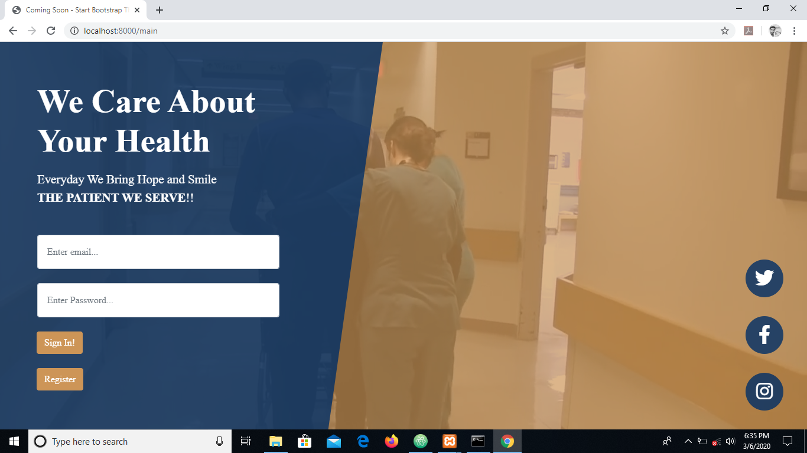

**Figure 2**

**Employee - Register Forms**

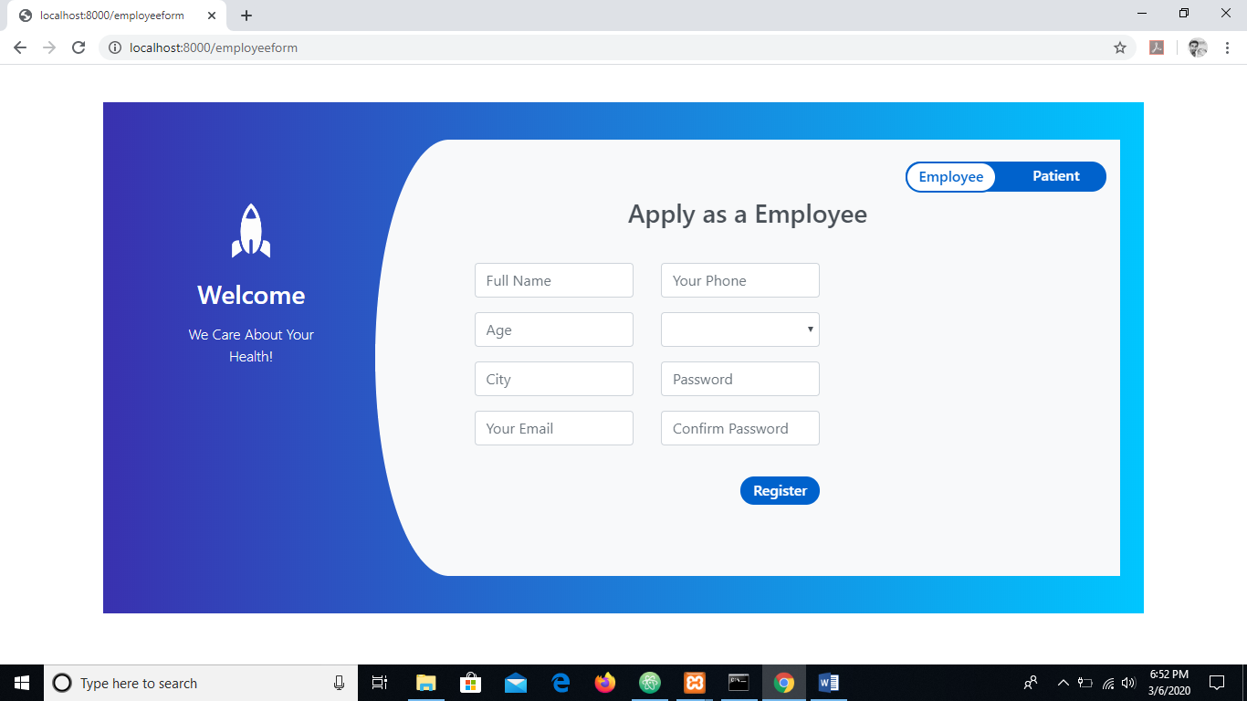

**Figure 3**

**Patient - Register Forms**

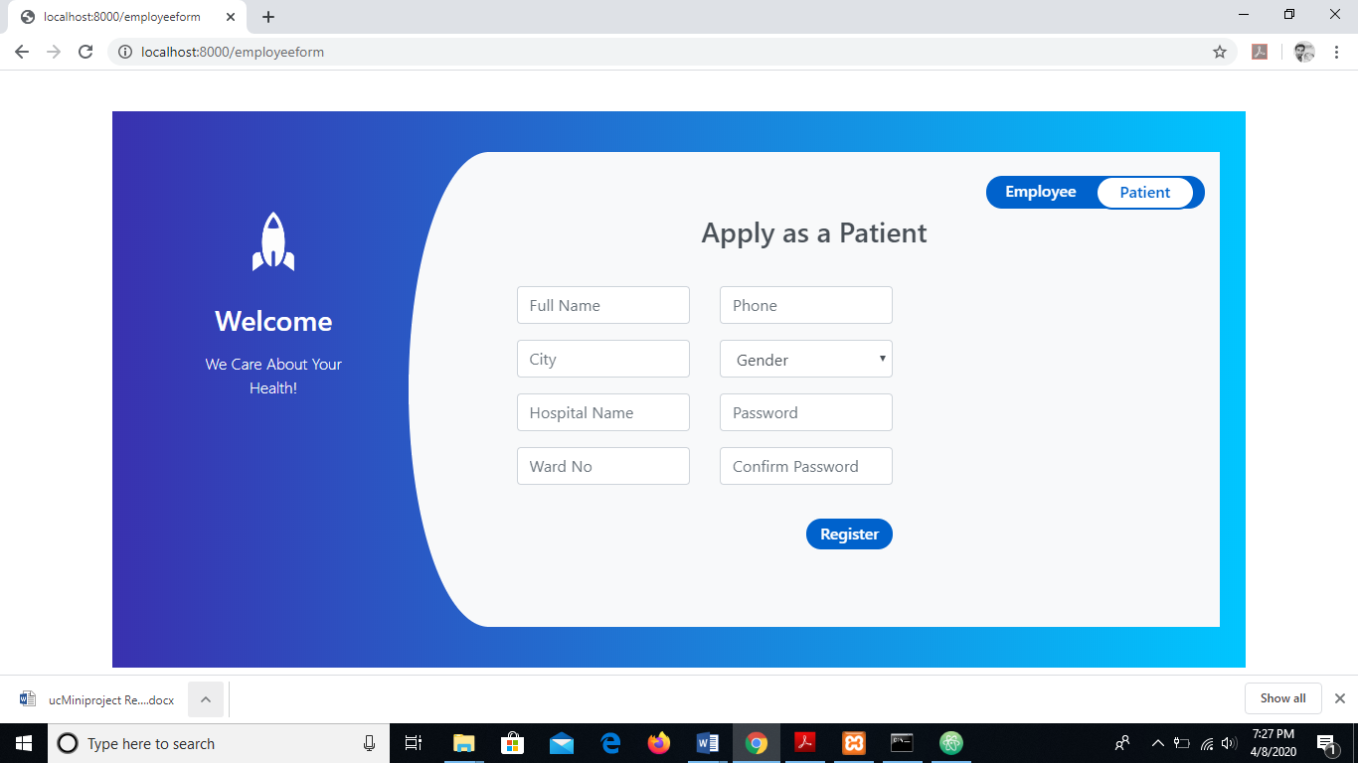

**Figure 4**

**Admin Dash Board**

After the Administrator login he can access this page. Only administrator can access this page. Administrator can log into the Hall mange, Inventory manage and user manage pages using this Admin Home form.

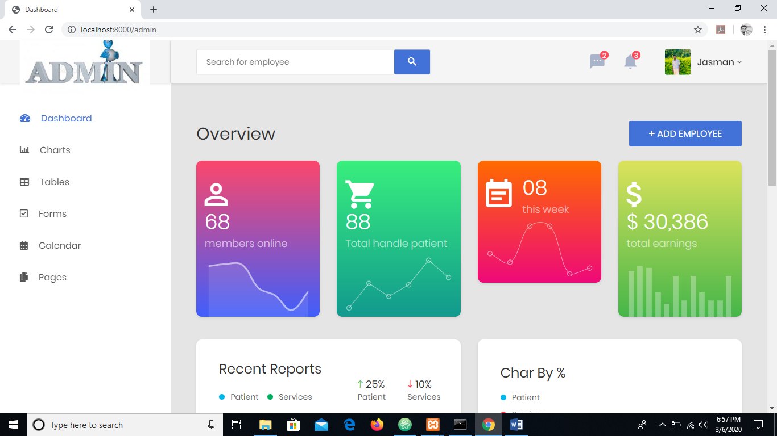

**Figure**

**Employee Data Table**

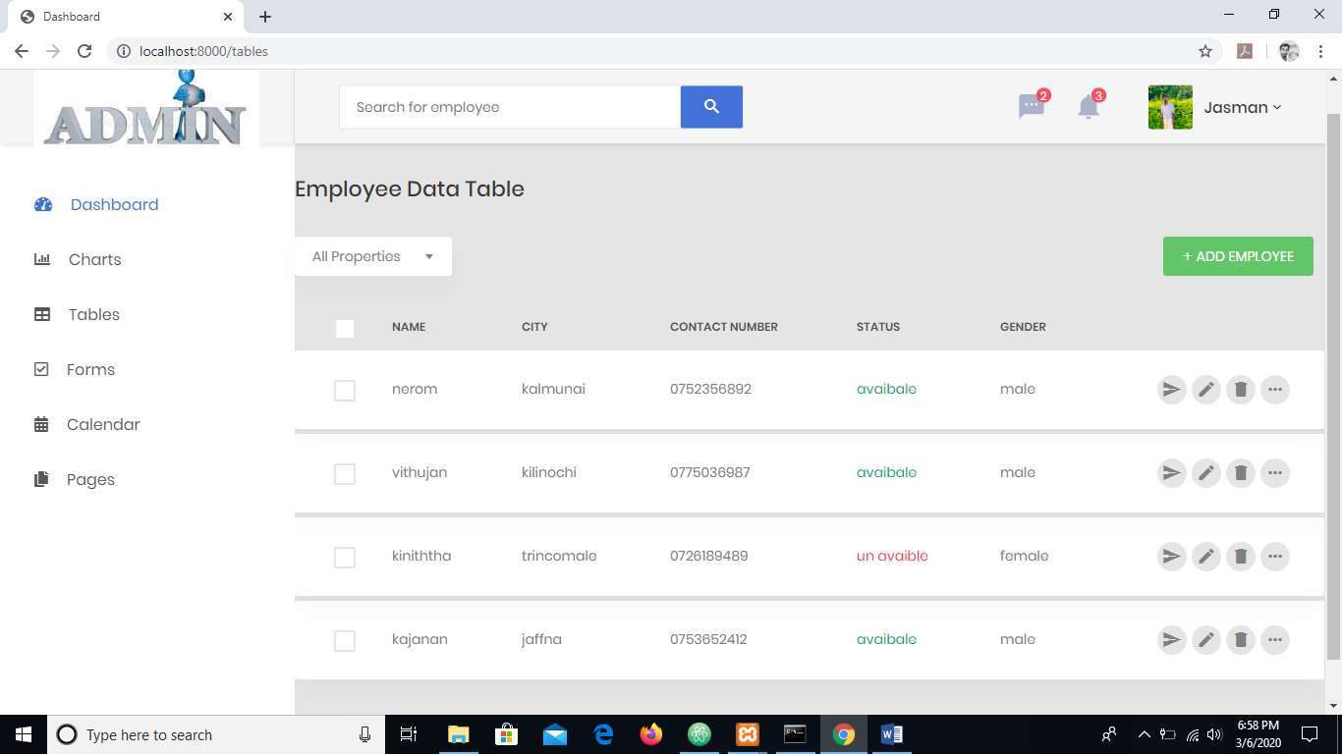 **Figure 6**

**Admin Chart**

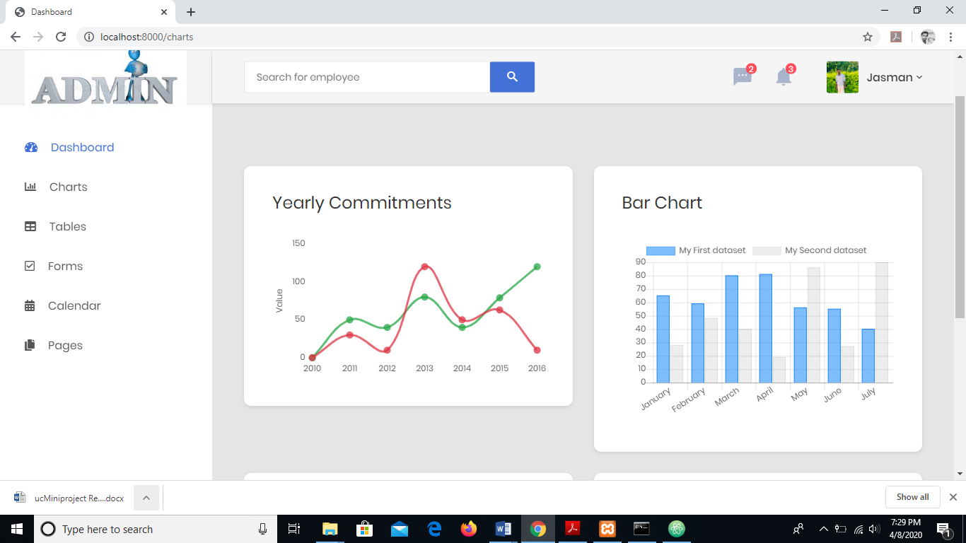

**Figure 7**

**4.2 Implementing algorithm and data structure**

Security is a primary goal of such a system. To ensure security, the system should have as many security features as user login to prevent unauthorized access, password authentication, ensure user authorization, and restrict browser redirect after logout from the system.

The greatest security feature is that password decryption methods are used for encryption.

The system used password hash algorithm MD5. Mainly, the use of a authentication system shielded any connection from unauthorized access. Administrators must insert their own predefined usernames and passwords in order to access and interact with the appropriate websites. And this is where the program was developed with complete validations. So, the user's incorrect or false information is limited.

**4.3 Over ambitious project aims**

* Give the work opportunity to the mechanics.
* Give the services to the people(users).
* Accuracy of Details.

**CHAPTER 5 - RESULT AND EVALUATION**

**5.1 Testing**

Testing is a vital part of software development, and it is important to start it as early

as possible, and to make testing a part of the process of deciding requirements.

Testing is helping to verify the project and make correction.

**5.2 Verification and Validation**

The web testing is tested during the code development. Testing is helping to verify the project and make correction. Verification is the process to make sure the product

satisfies the conditions and terms imposed at the start of the development phase.

Validation is the process to make sure the product satisfies the specified

requirements at the end of the development phase. In other words, to make sure the

product is developed as per customer requirements.

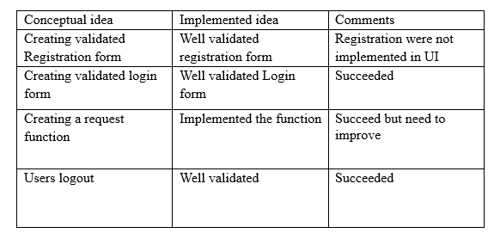**5.3 Evaluation**

## 

## **5.4 Functional Testing**

Test for all the links in web pages, database connection, forms used in the web pages for submitting or getting information from user, Cookie testing.

**5.5 Check all the links**:

* Test the outgoing links from all the pages from specific domain under test. Such as index page.
* Test all internal links. Such as buttons in pages.
* Test jumping on the same pages.
* Test to check if there are any orphan pages.
* Lastly in link checking, check for broken links in all above-mentioned links.

**5.6 Test the forms in all pages**:

* First check all the validations on each field.
* Check for the default values of fields.
* Wrong inputs to the fields in the forms.
* Options to create forms if any, form delete, view or modify the forms.

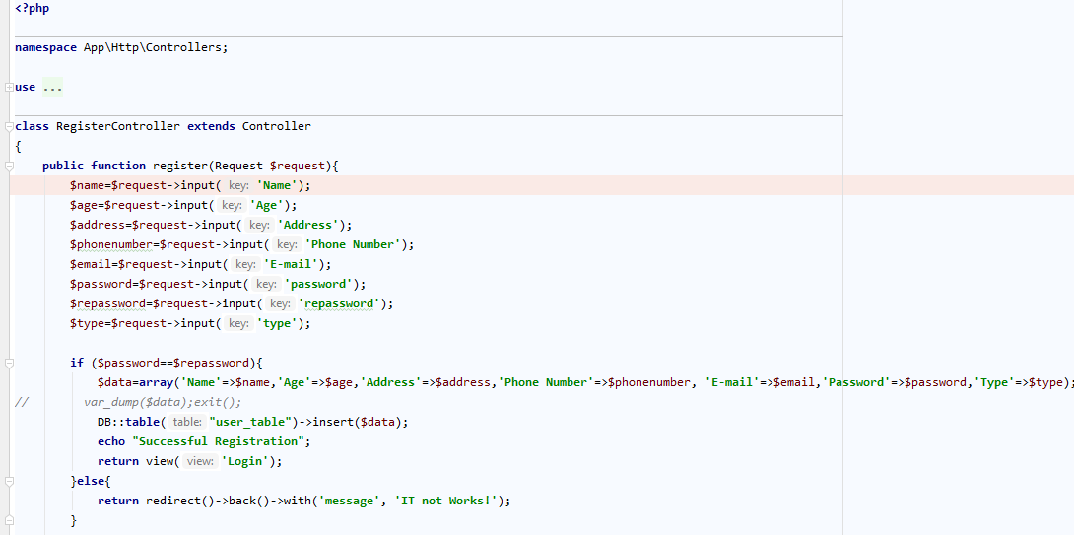

**Figure 8 -**Provide account create security

**5.7 Cookies Testing**:

* Testing cookies (sessions) are deleted either when cache is cleared or when they reach their expiry.
* Delete cookies (sessions) and test that login credentials are asked for when you next visit the site.
* If the browser closes without logout also, session cookie is destroyed.

**5.8 Interface Testing**

Three areas to be tested here are - Application, Web and Database Server

* Application: Test requests are sent correctly to the Database and output at the

client side is displayed correctly. Errors if any must be caught by the

application and must be only shown to the administrator and not the end user.

* Web Server: Test Web server is handling all application requests without any

service denial.

* Database Server: Test and Make sure queries sent to the database give

expected results.

**5.9 Database Testing**

* Database is one critical component of web application and stress must be laid to test it thoroughly.
* Test if any errors are shown while executing queries.
* Data Integrity is maintained while creating, updating or deleting data in database.
* Check response time of queries and fine tune them if necessary.
* Test data retrieved from your database is shown accurately in your web application.

**CHAPTER 6 – FUTURE WORKS**

In this chapter I’m going to describe about the modifications of this web based hospital bystander management web system. The main things which I planned in future are:

* Develop the phone number instead of email address of the patient in the login page of the patient.

Some patients forgot their email address passwords. So it will be more beneficial to the patients to access the caretaker in that difficult situation.

* Link the patient address in the web system to a google map.

This will enable the caretakers to access the patient’s exact location.

* Develop a web page in my web system for the blood bank and blood donation management.

It will help to the blood recipient to search required donor based on the blood type and help to the patient, whether the particular type of blood is available or not in the blood bank.

* Develop some admin parts.
* Develop this system in a mobile application for IOS and android users.

**CHAPTER 7 – CONCLUSION**

* The major goal of this project was to build an effective web system for the hospitalized persons who are in nuclear families. This web system mainly considers on providing polite accountable trustworthy persons for caretaking service against the fake local people. The latest technologies were used to develop the web system which takes less than two seconds to load the page.

This project gave me valuable in a timely manner, I learnt how to handle the stress situation in a project. I was a good experience in my life. Following are some of lessons learnt:

* During the developing I learnt how to create three levels of authentication for admin, caretaker, and patient who have different account.
* Some database normalization issues arose while doing this project. Since solving these issues, it helps me to improve my database knowledge.
* Since searching larval frameworks (PHP), Angular js and My SQL it helps me to improve my programming language.
* mobile application for IOS users and android mobile users.

**CHAPTER 8 – References**

* Where is the Bystander? - https://palliumindia.org/2011/11/where-is-the-bystander/
* Bystander Intervention in Out of Hospital Cardiac Arrest-https://jamanetwork.com/journals/jamanetworkopen/fullarticle/2729463
* Patient Guide-http://kristujayantihospital.com/patiet_guide.html
* Hospital Health Information Management System (HHIMS)-http://www.eswabhimani.lk/media-gallery/2-uncategorised/251-hospital-health-information-management-system-hhims
* Hospital Management System: Features, Modules, Functions, Advantages-https://medium.com/existek/hospital-management-system-features-modules-functions-advantages-1aa2a0857bf
* Ward management- <https://pharmacolog.com/ward-management/>

**CHAPTER 9 – GLOSSRAY**

|  |  |
| --- | --- |
|  | Secure web server developed by Apache Software foundation. |
| CSS | Stands for Cascading Style Sheets. Use to apply styles for  Markuplanguages such as HTML, XML. |
| HTML | Stands for Hyper Text Markup Language. Use to build Web  pages. |
| MySQL | One of most popular Database management system can handle  big amount of data related to different types. |
| PHP | Stand for PHP Hypertext Preprocessor. Object oriented supported  server side scripting language. |
| xampp | Cross platform, Apache, MariaDB, PHP and Perl. |
| SQL | Stands for Structured Query Language. Help to retrieve data base  details. |
| MD5 | (Message Digest Algorithm) Use when converting data into  unreadable format. |

**CHAPTER 10 – APPENDICES**

**Appendix A: System documentation**

This documentation consists of a set of steps to show, how to install this Student

Management System. These steps explain about the hardware and software

environment which needs to be installed. When installing the system, this

documentation can be followed by the interested parties.

**Hardware Requirement**

* 8 GB RAM
* Intel Core i5 6100 @2GHz Processor
* 1 TB Hard Disk
* Mouse & Keyboard

**Software Requirement**

* HTML
* CSS
* Angular js
* PHP (Laravel Frame works)
* My SQL